STEP 1)

Created two EC2 Instances. Both t2 tier eligible and running Ubuntu os on them. Configured the security groups on both of them.

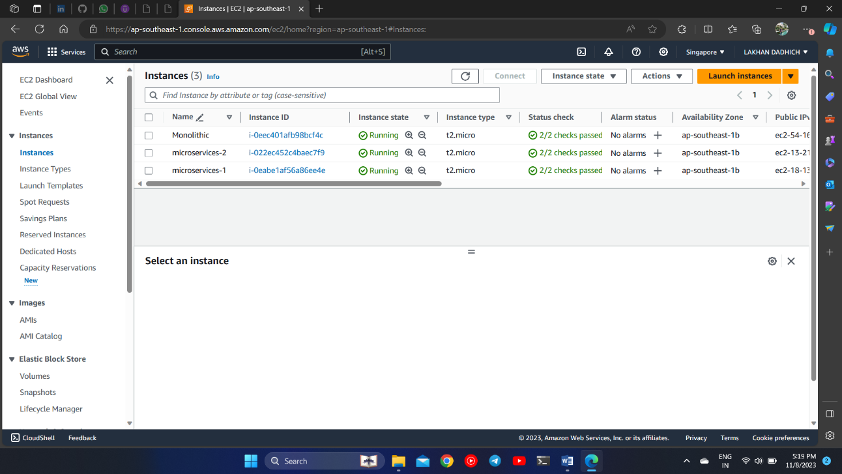

STEP 2)

On instance 1, microservices-1 installed MariaDB, MySQL server along with the Lamp Stack Package.

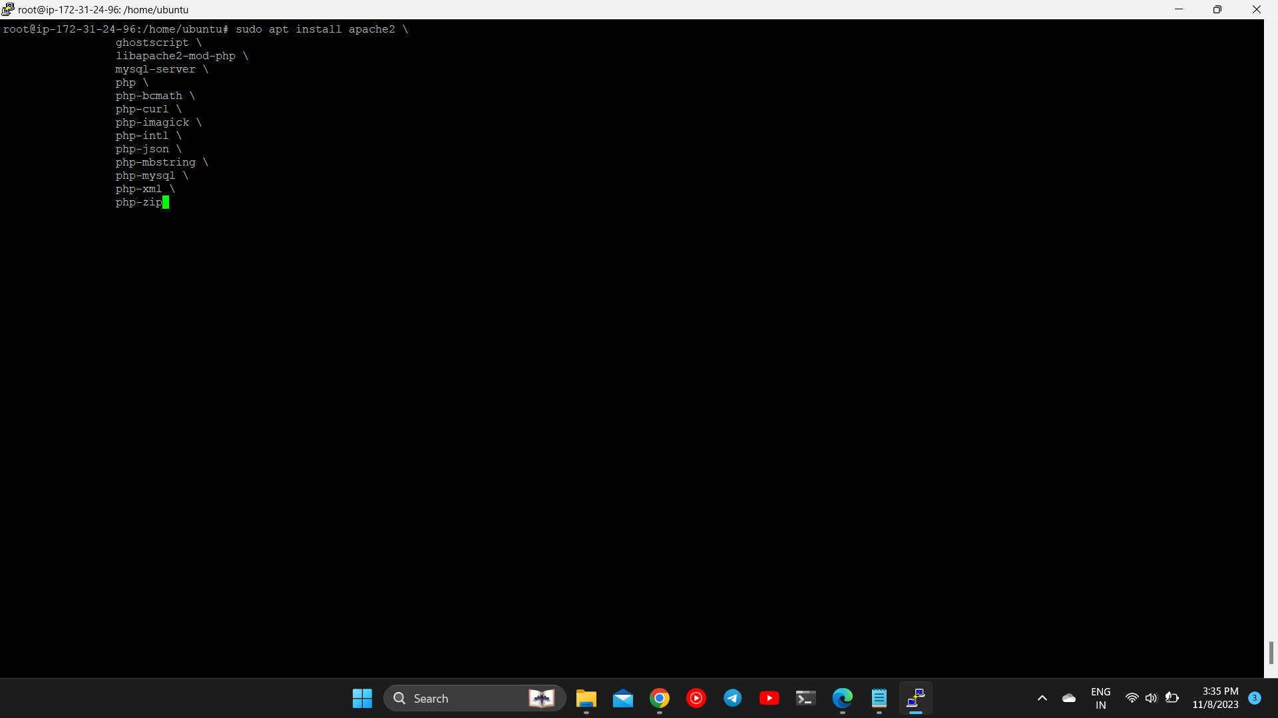

STEP 3)

Configured the MySQL Database.

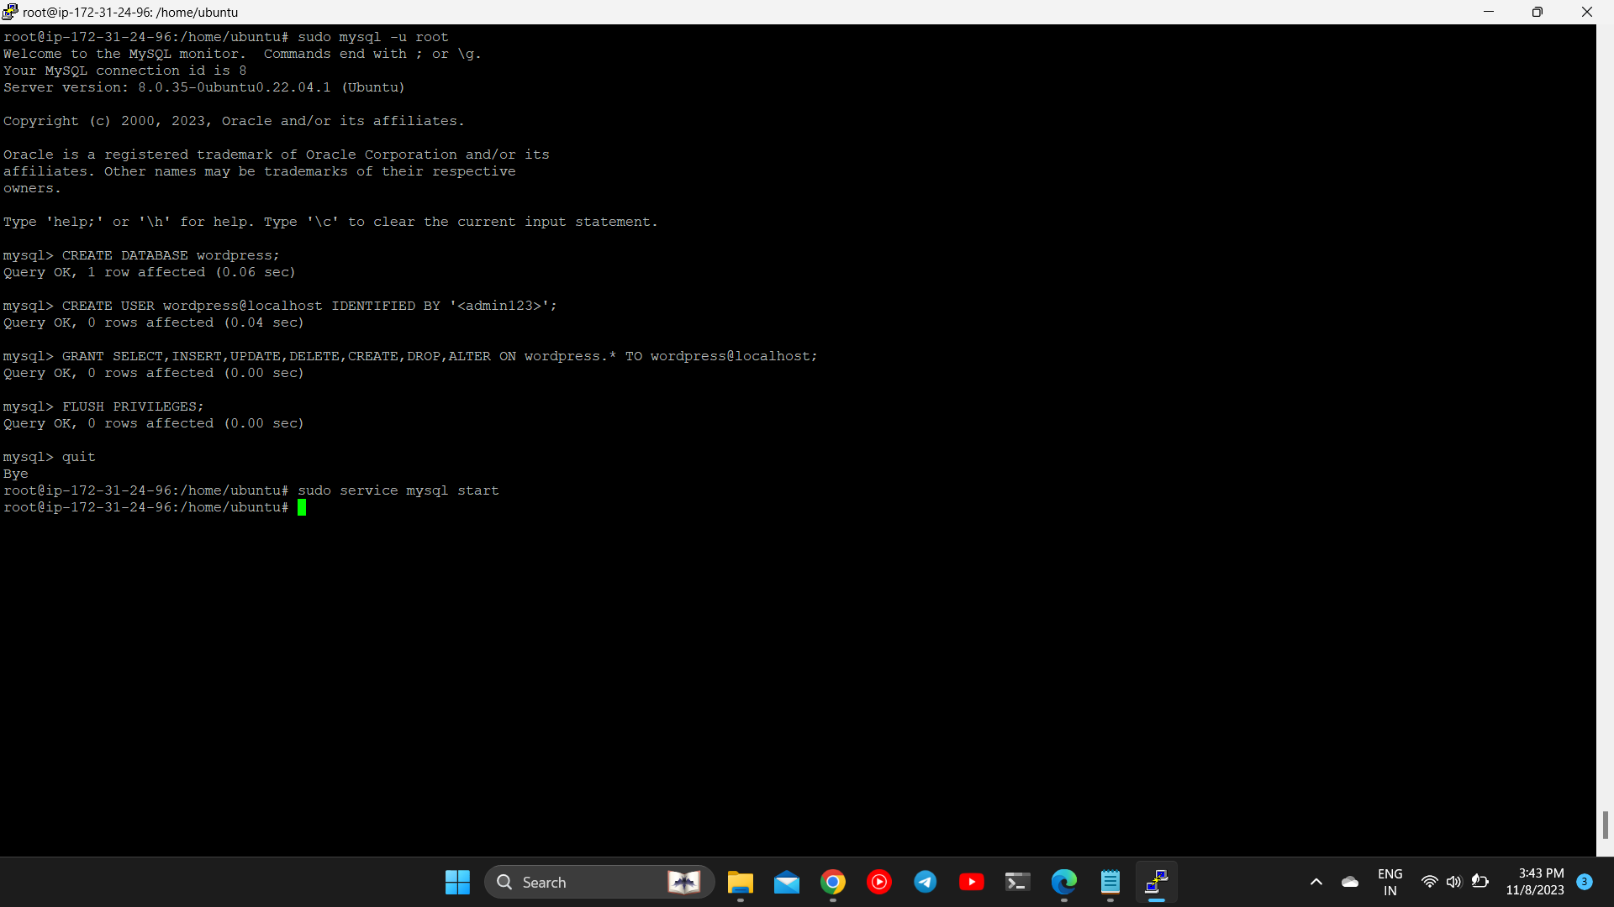STEP 4)

On another EC2 instance : microservices-2 Installed Lamp Stack Package and Wordpress.

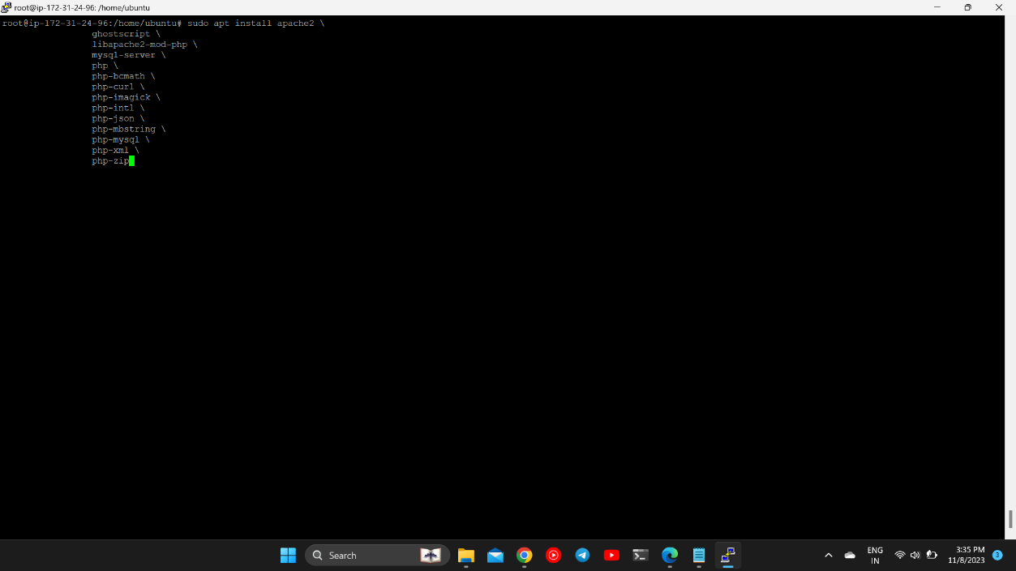

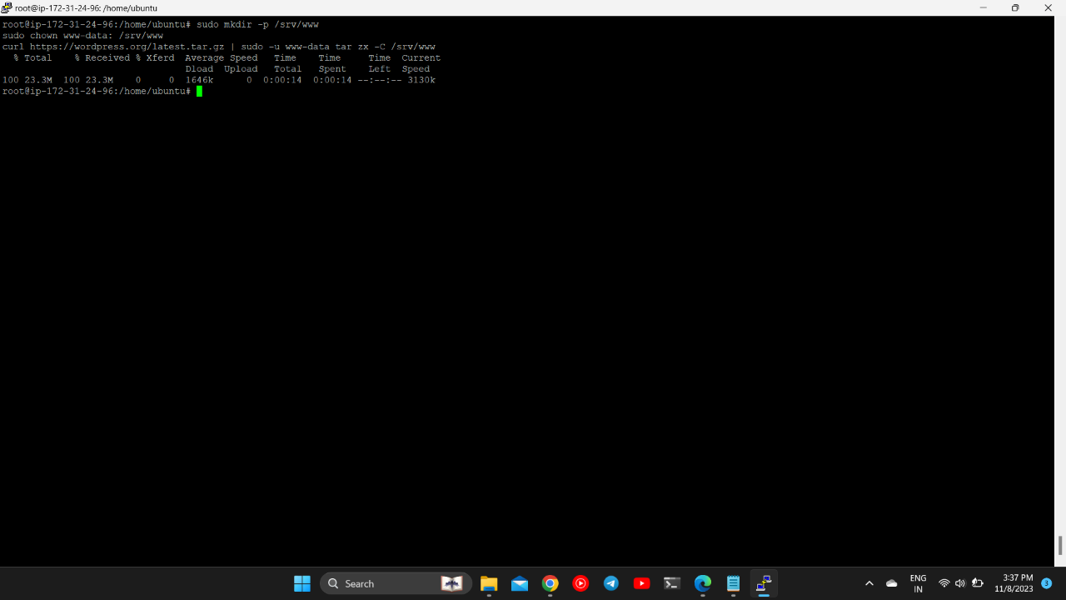

STEP 5) Created Apache file and Configured apache for wordpress.

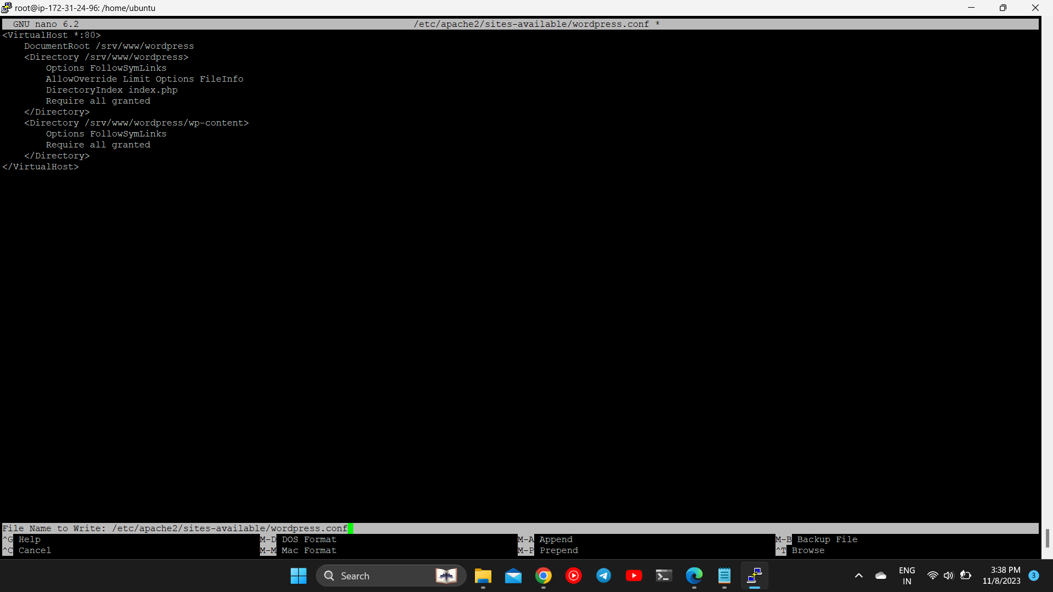

STEP 6)

Configured Wordpress and Connected it to the Database. Configured the wp-config.php file and added the secret AUTH key to it.

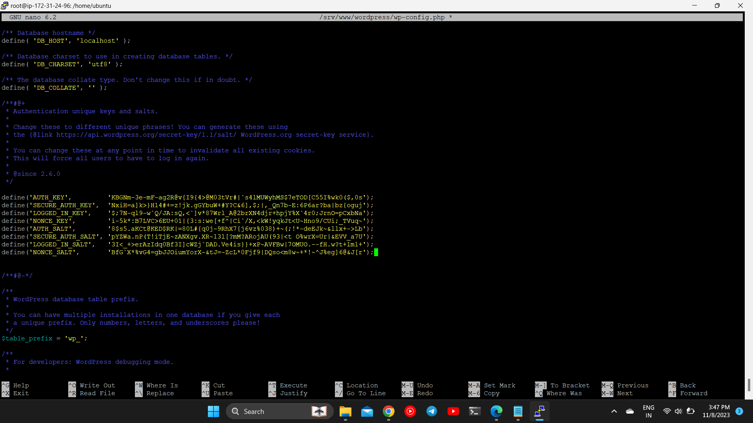

STEP 7)

Configured Wordpress.

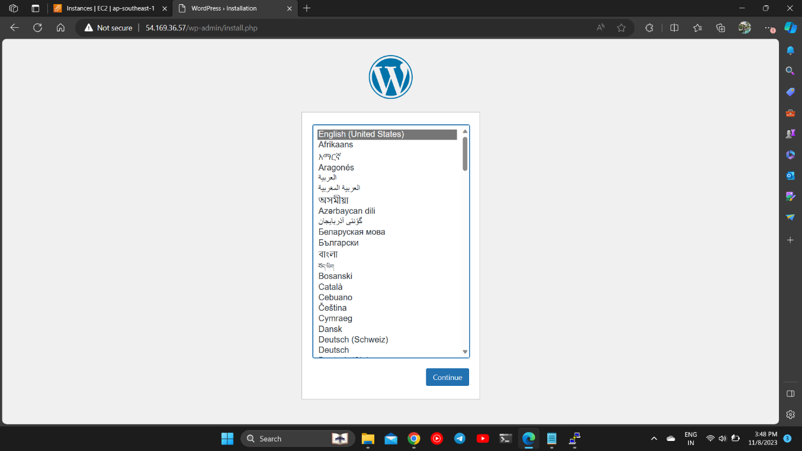

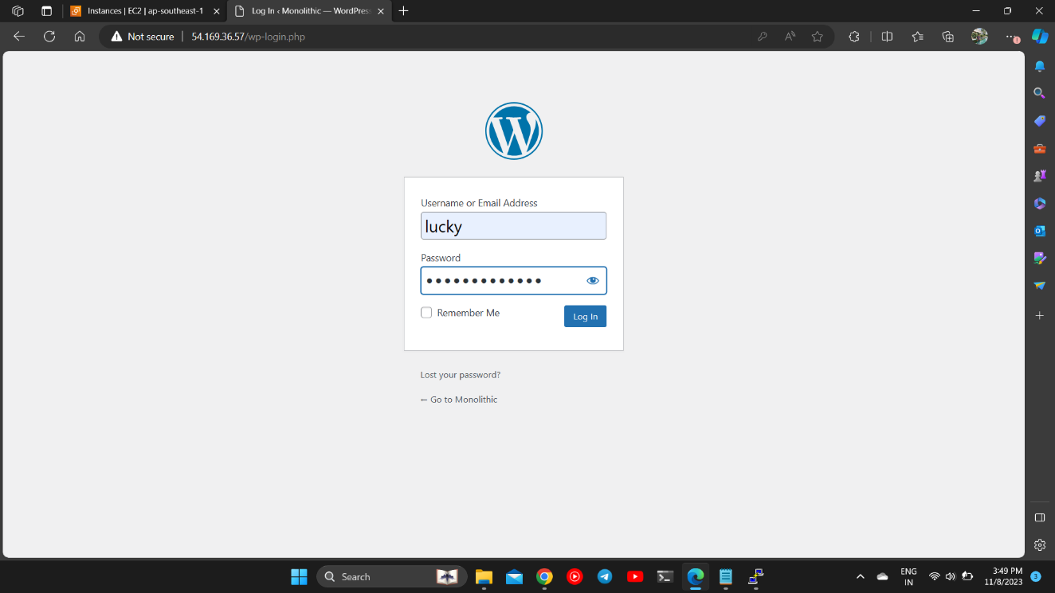STEP 8)

Created a new post and Deployed/published it live.

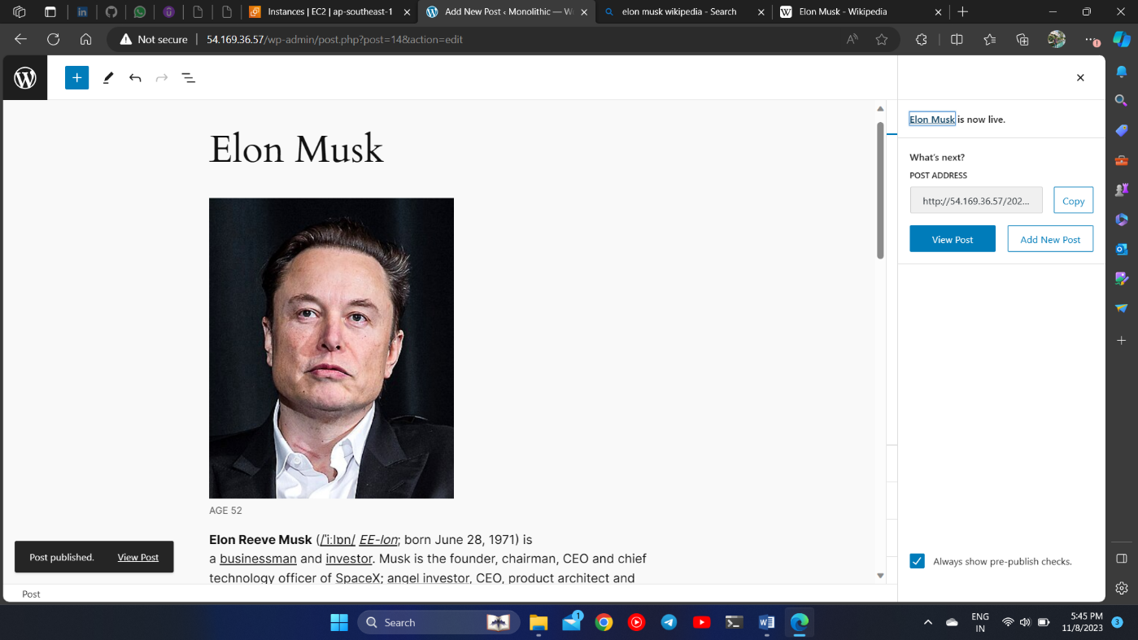

STEP 9)

You can now visit our live page which gives us information about our rising star Virat Kohli.

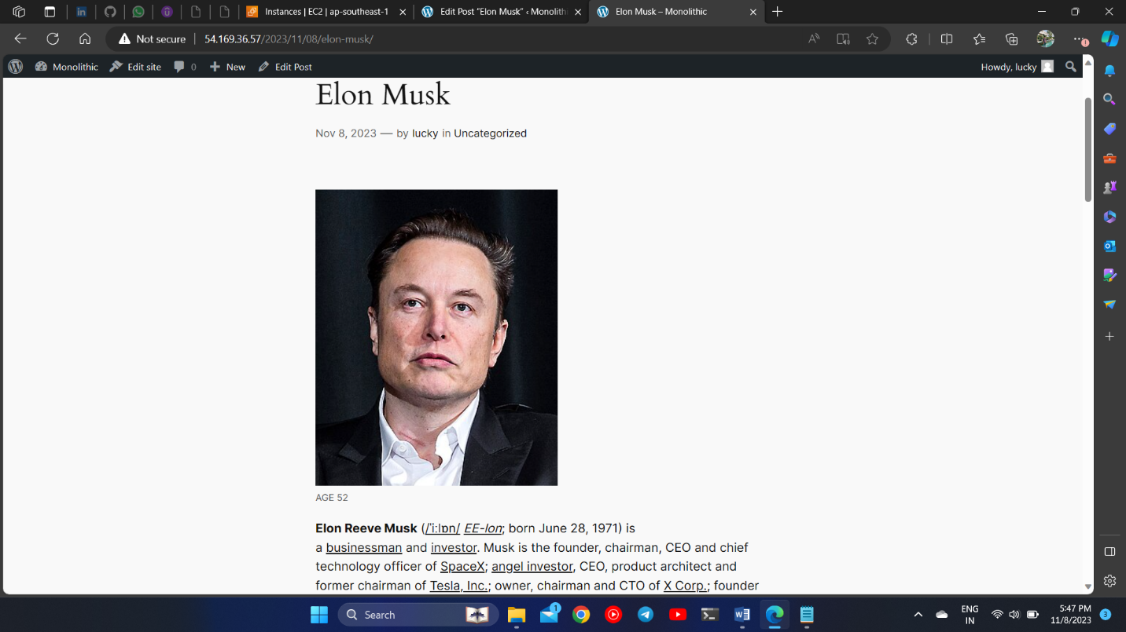 Page Link : <http://54.169.36.57/2023/11/08/elon-musk/>